**Ecommerce Application**

**CREATION OF TABLES:**

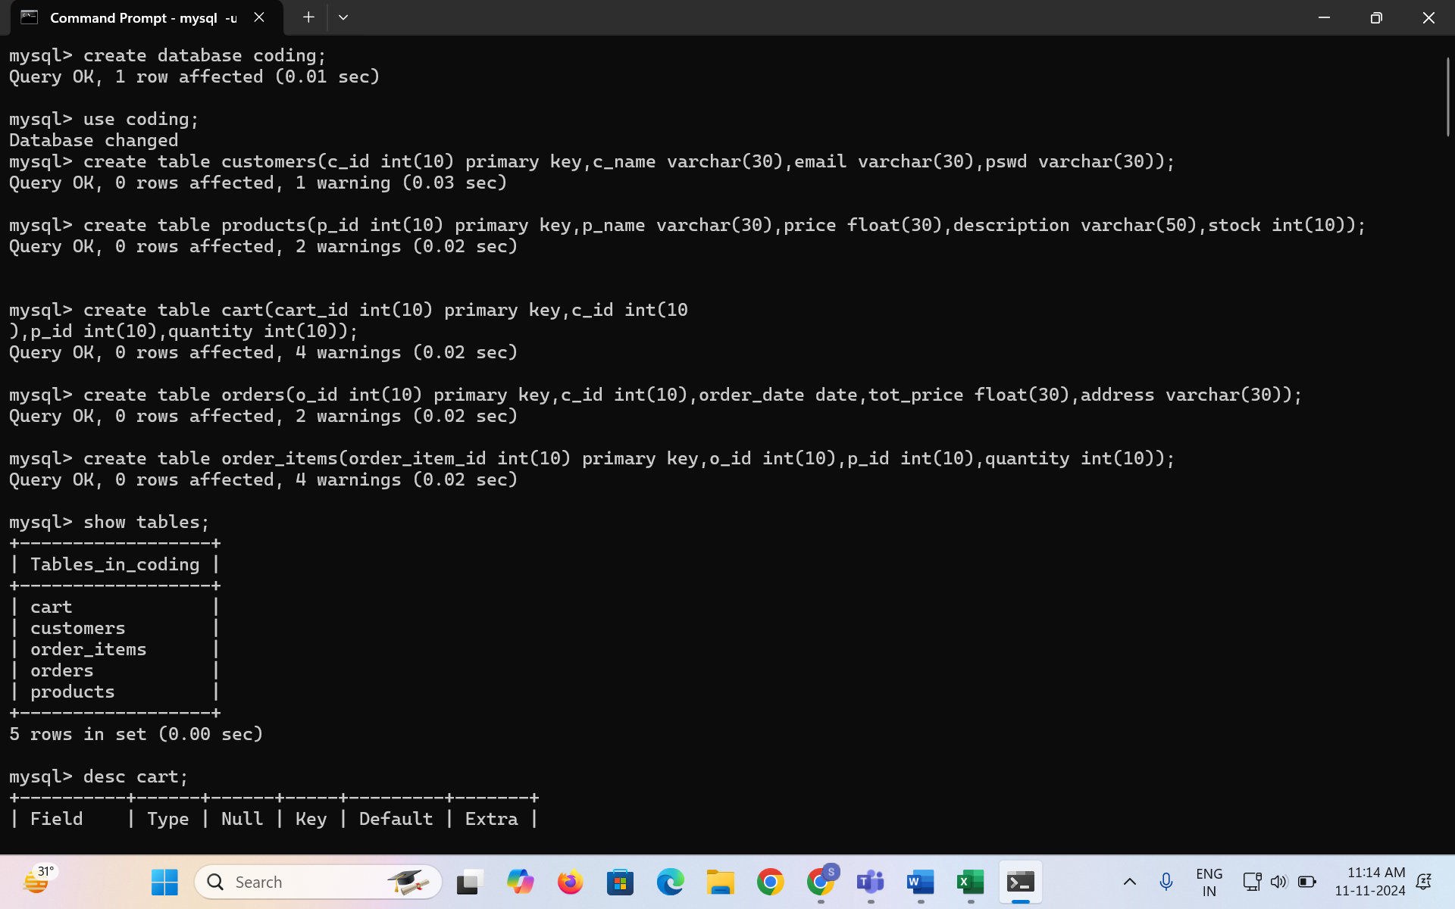

**INSERTING VALUES TO EACH TABLE:**

**CART TABLE:** 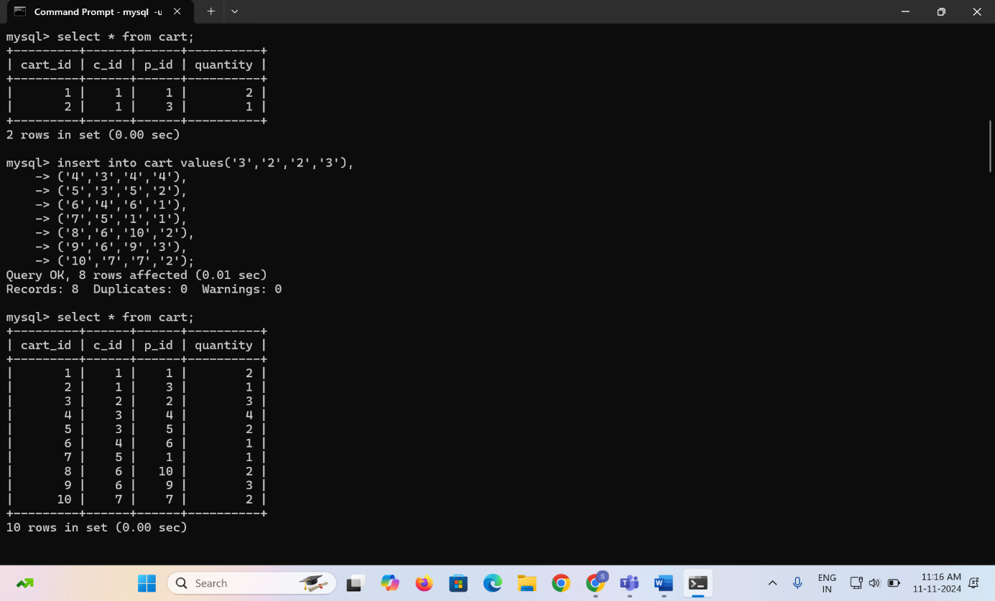

**ORDER_ITEMS TABLE:**

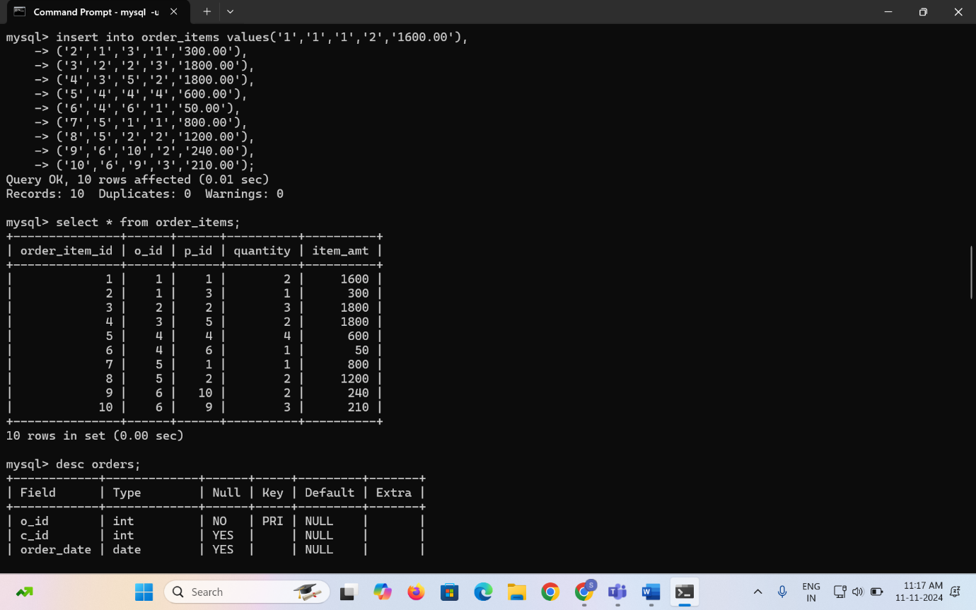

**ORDERS TABLE:**

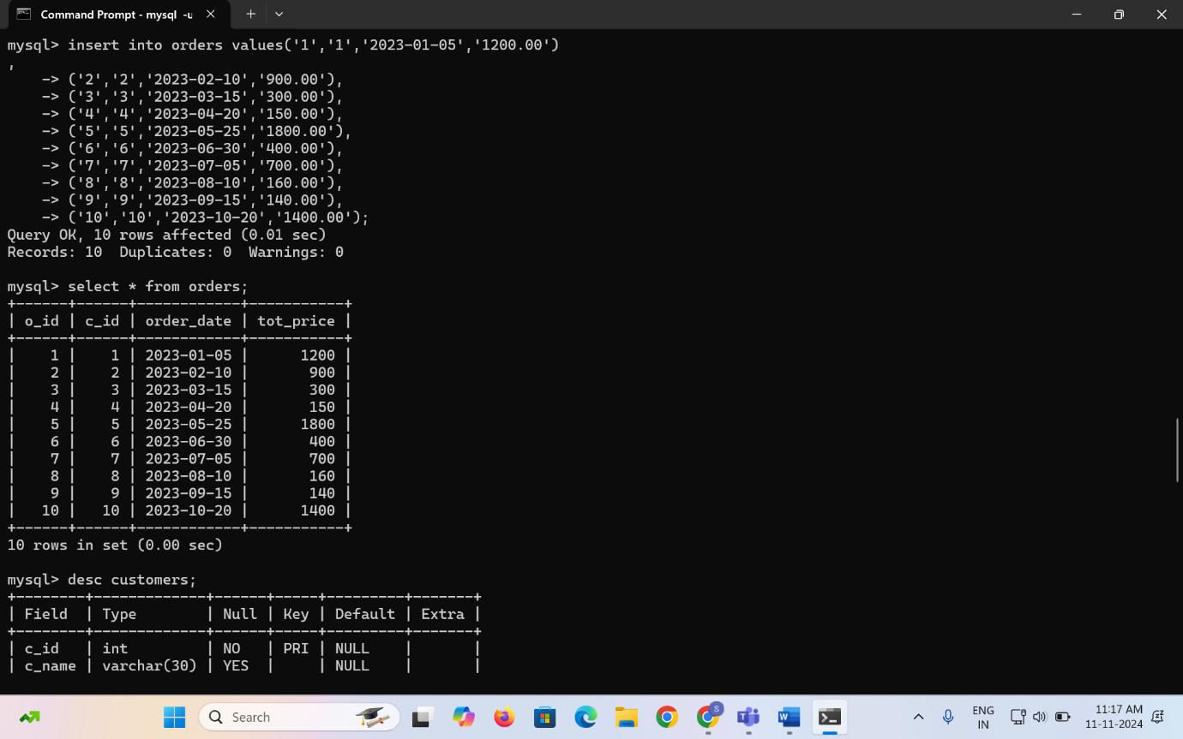

**CUSTOMERS TABLE:**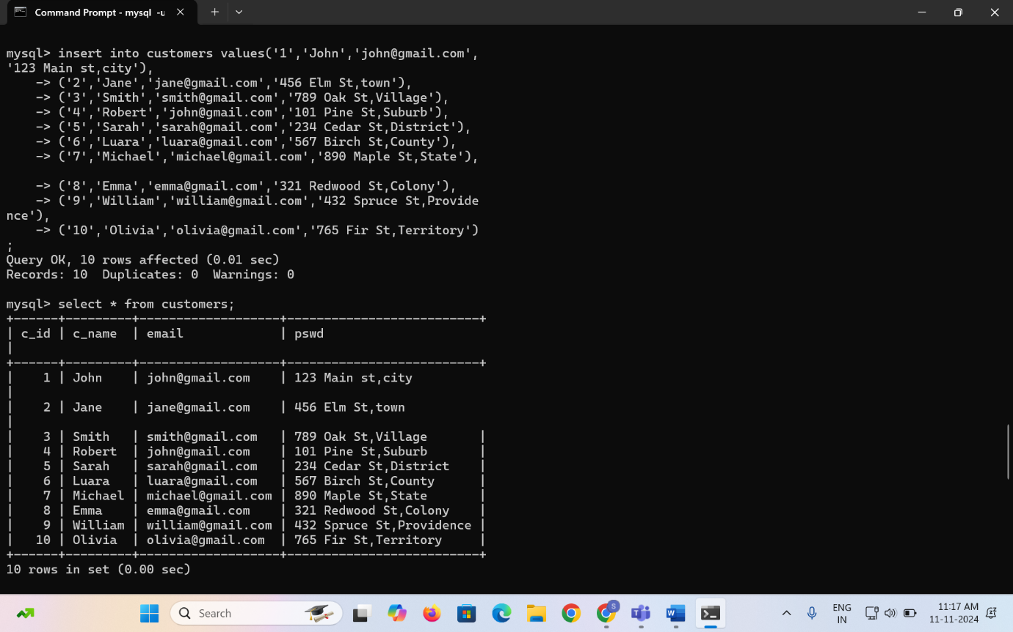

**PRODUCTS TABLE:**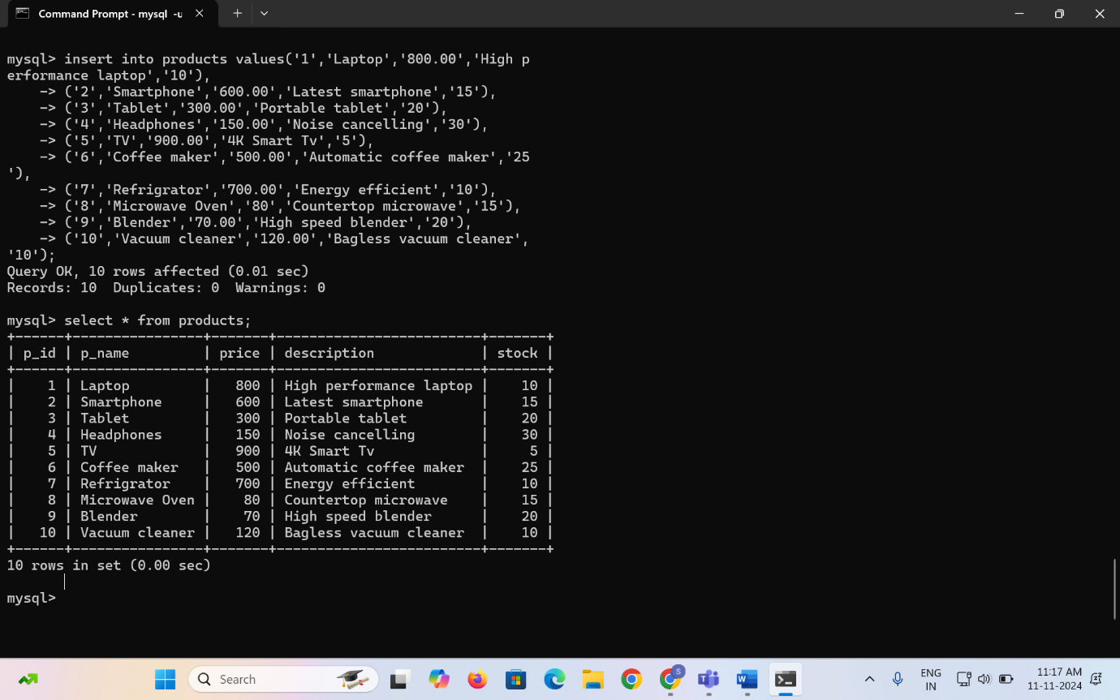

**QUERIES FOR THE GIVEN QUESTIONS**

**QNS 1:Update refrigerator product price to 800.**

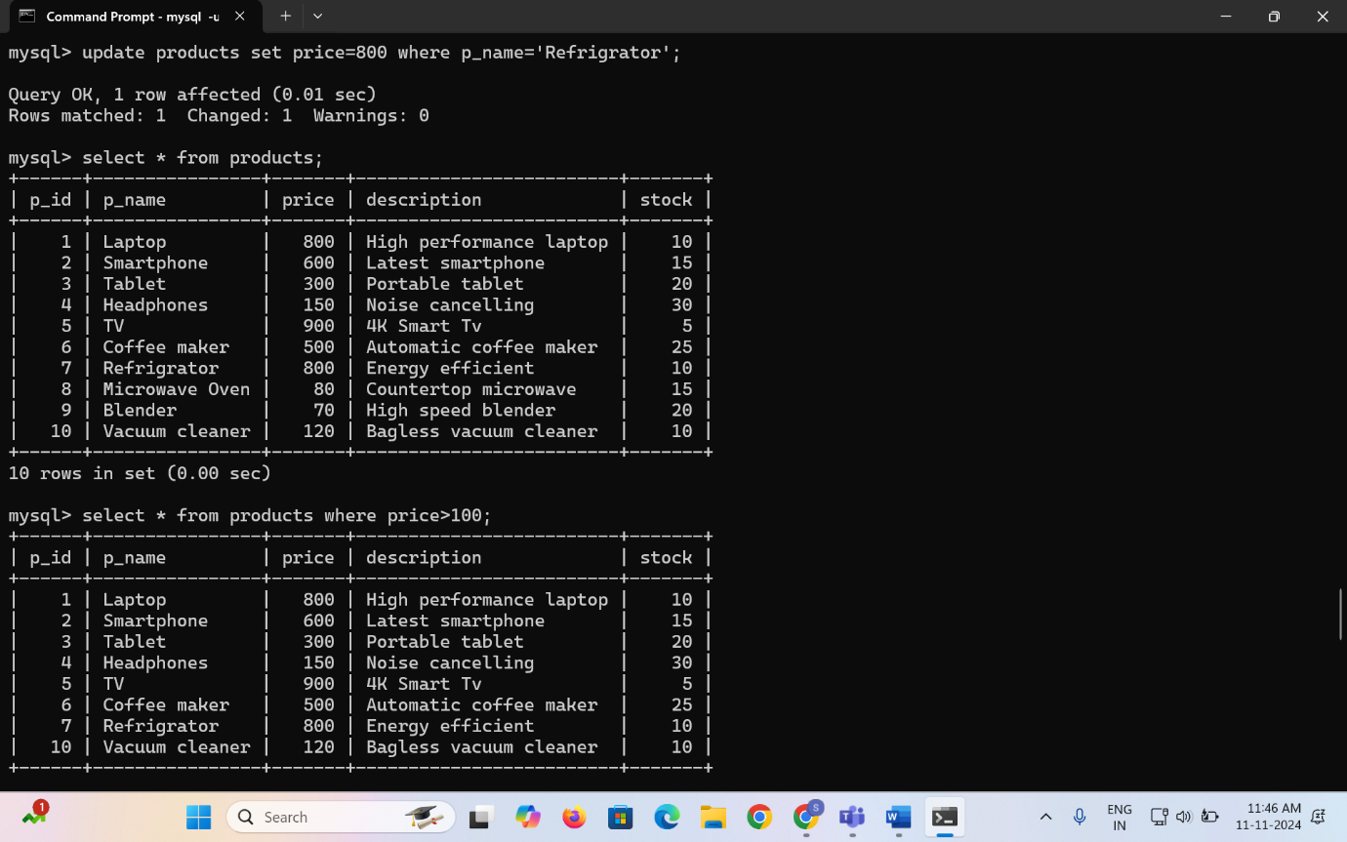

**QNS 2: Remove all cart items for a specific customer**



**QNS 3:** **Retrieve Products Priced Below $100.**

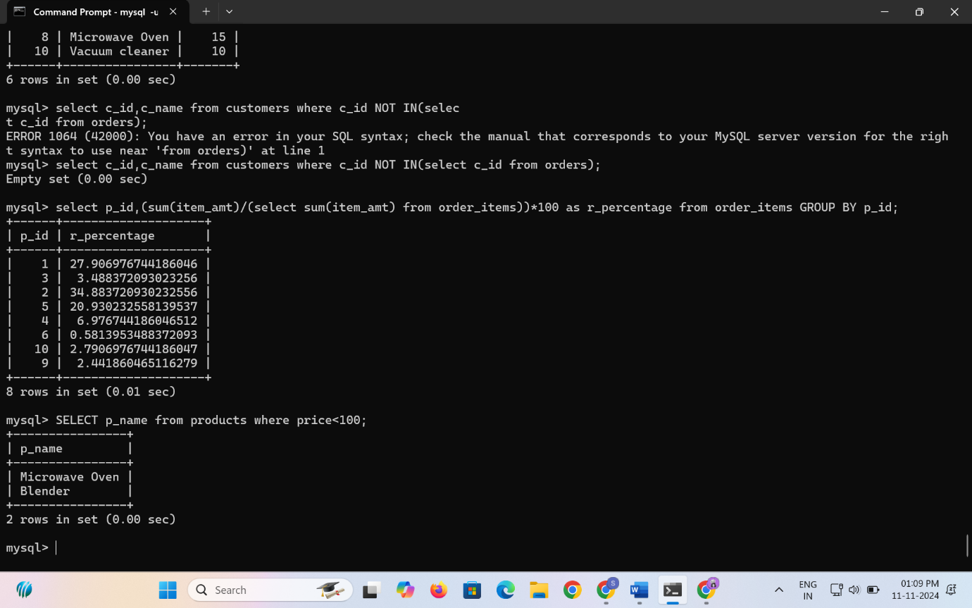

**QNS 4: Find Products with Stock Quantity Greater Than 5.**

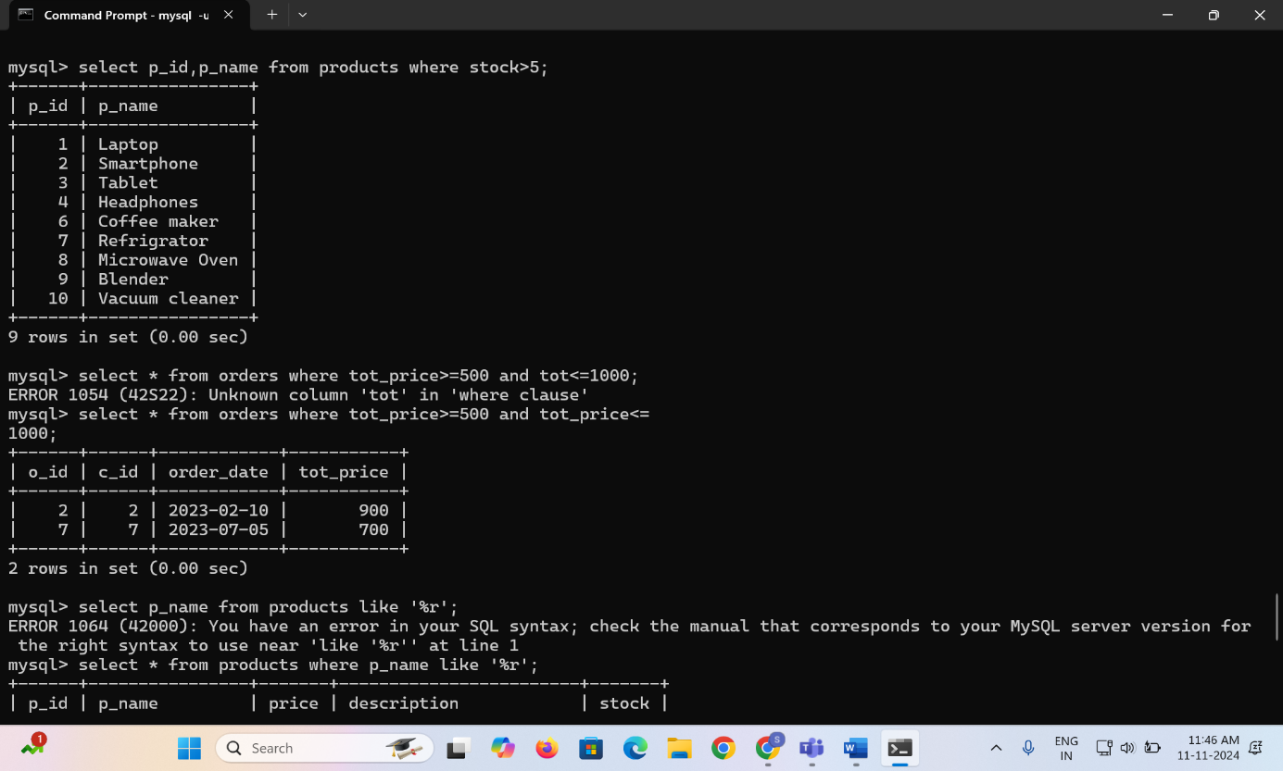

**QNS 5: Retrieve Orders with Total Amount Between $500 and $100.**

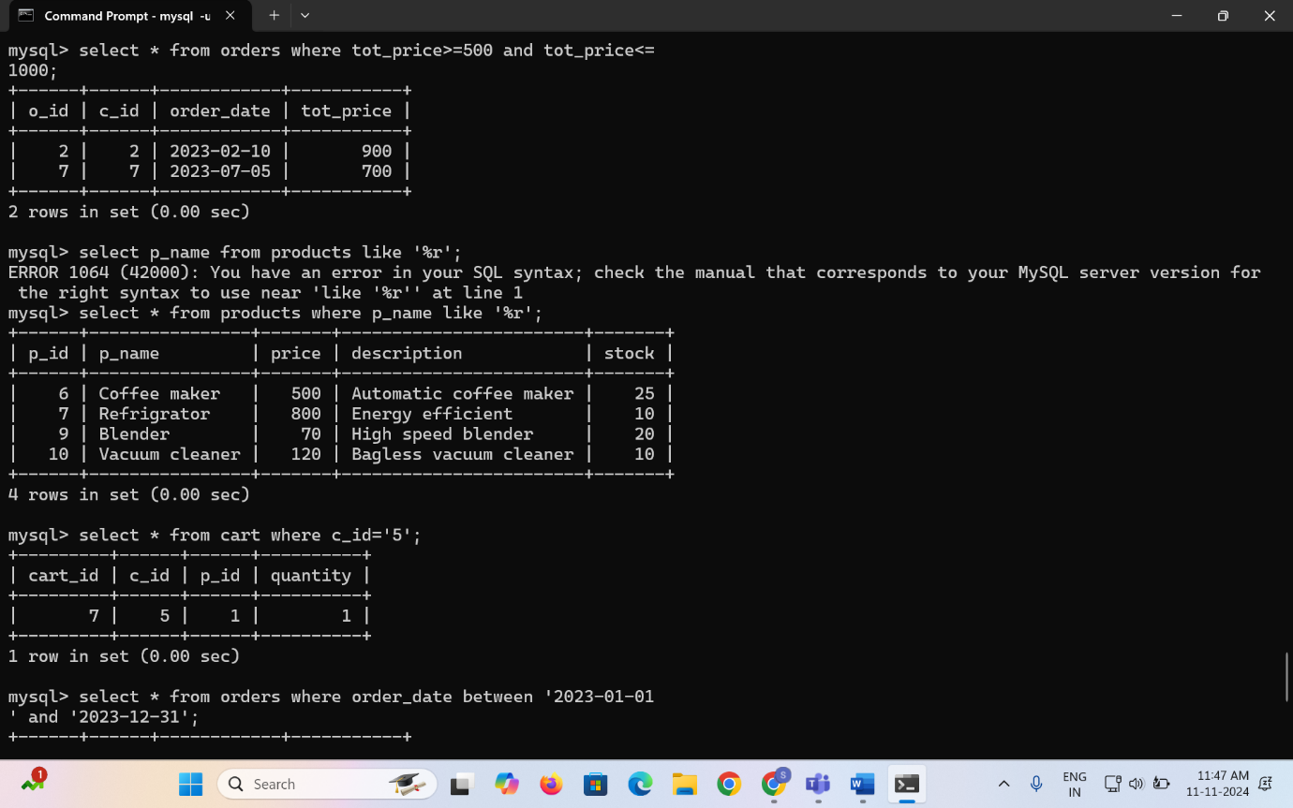

**QNS 6: Find Products which name end with letter ‘r’**

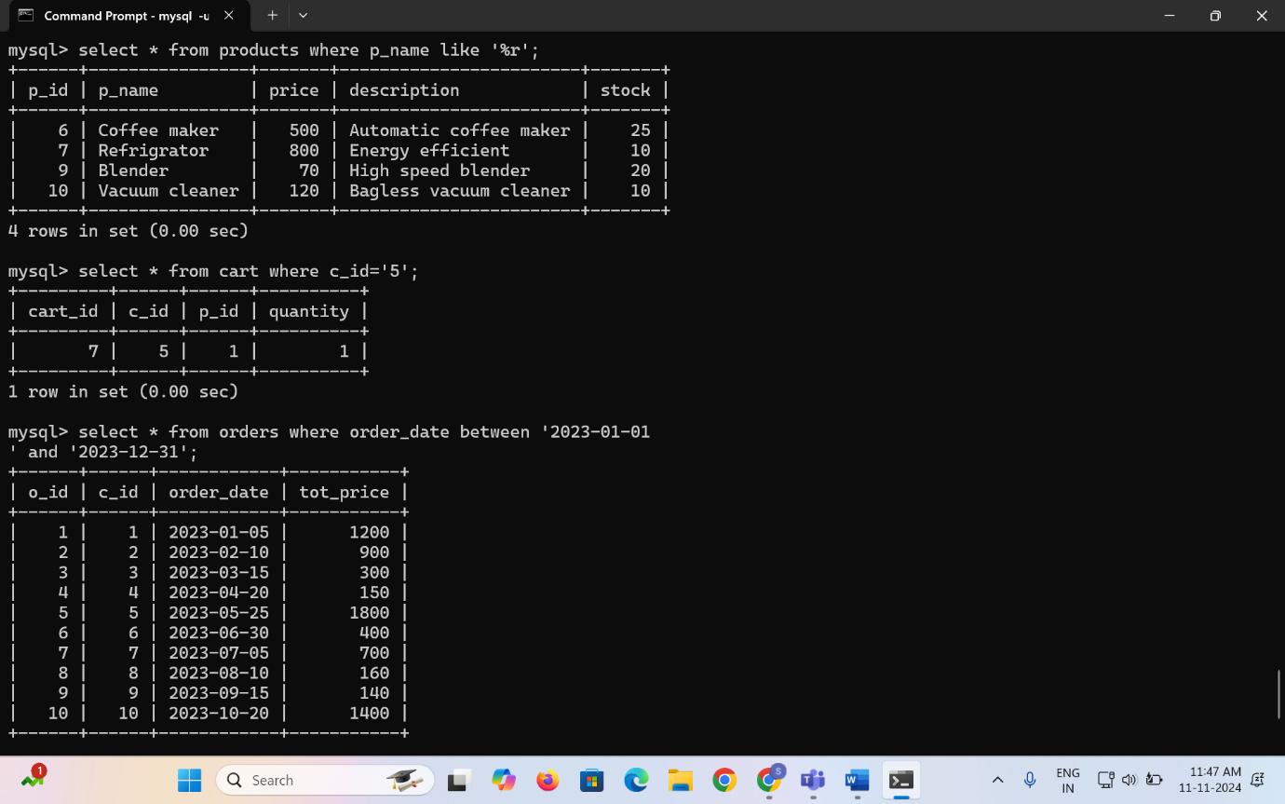

**QNS 7: Retrieve Cart Items for Customer 5.**

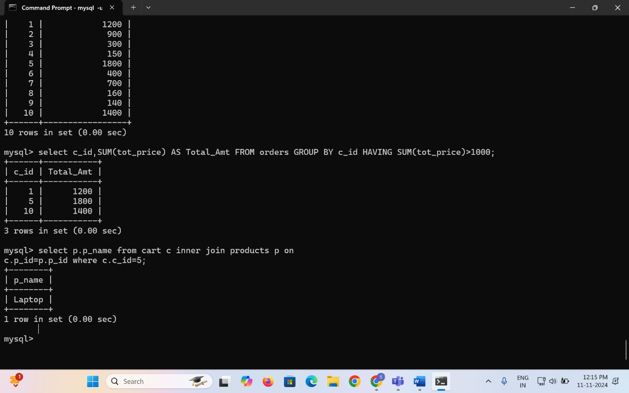

**QNS 8: Find Customers Who Placed Orders in 2023.**

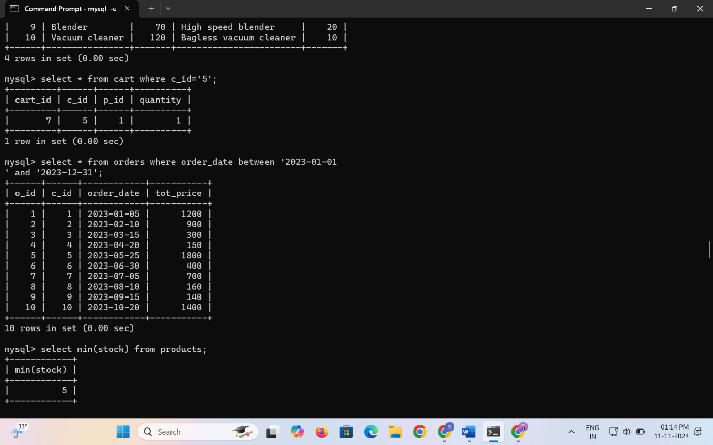

**QNS 9:** **Determine the Minimum Stock Quantity for Each Product Category.**



**QNS 10: Calculate the Total Amount Spent by Each Customer.**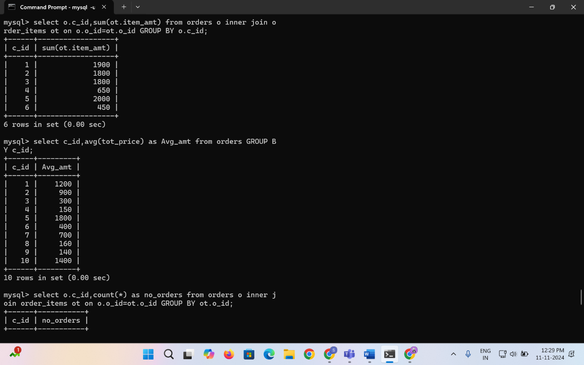

**QNS 11: Find the Average Order Amount for Each Customer**



**QNS 12: Count the Number of Orders Placed by Each Customer**

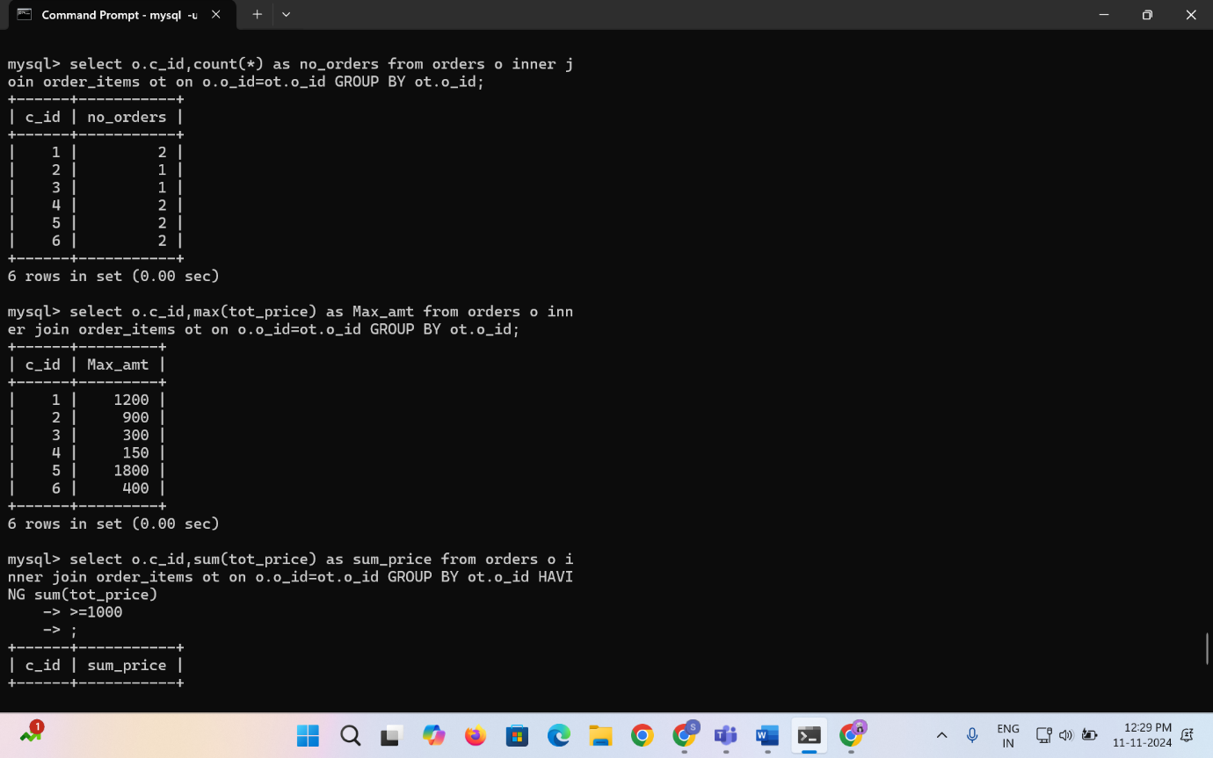

**QNS 13: Find the Maximum Order Amount for Each Customer.**



**QNS 14: Get Customers Who Placed Orders Totaling Over $1000**

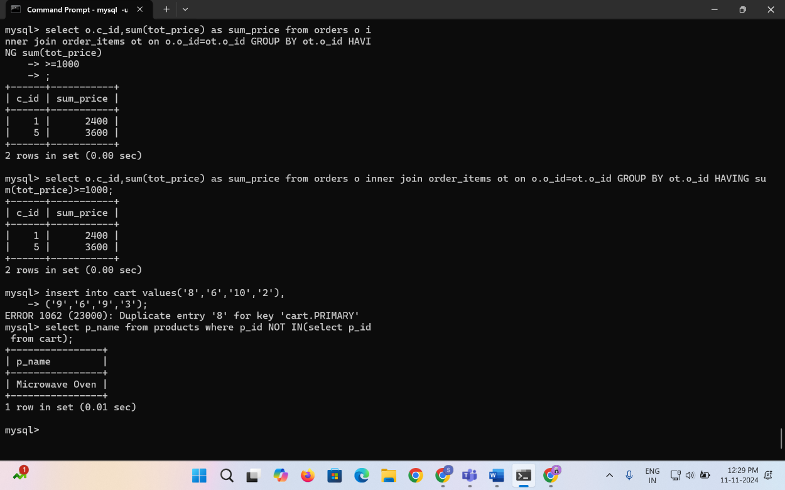

**QNS 15: Subquery to Find Products Not in the Cart**

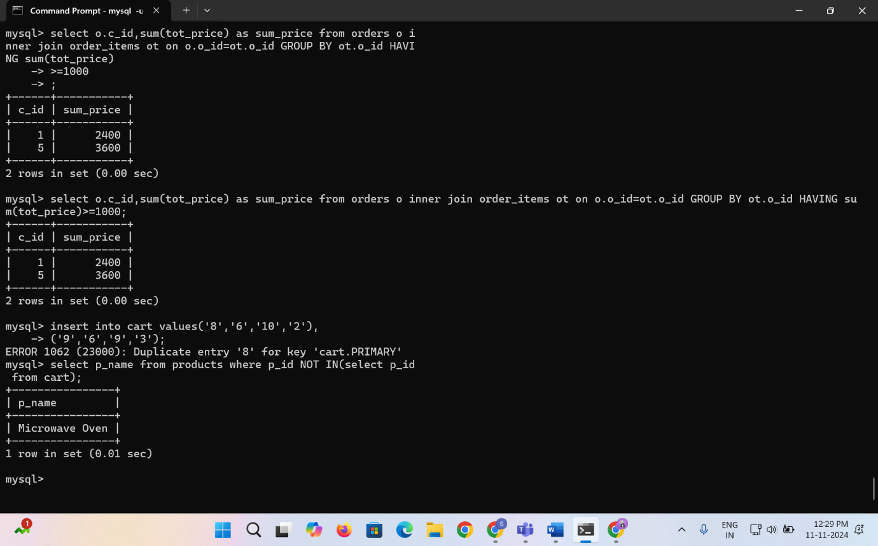

**QNS 16: Subquery to Find Customers Who Haven't Placed Orders**

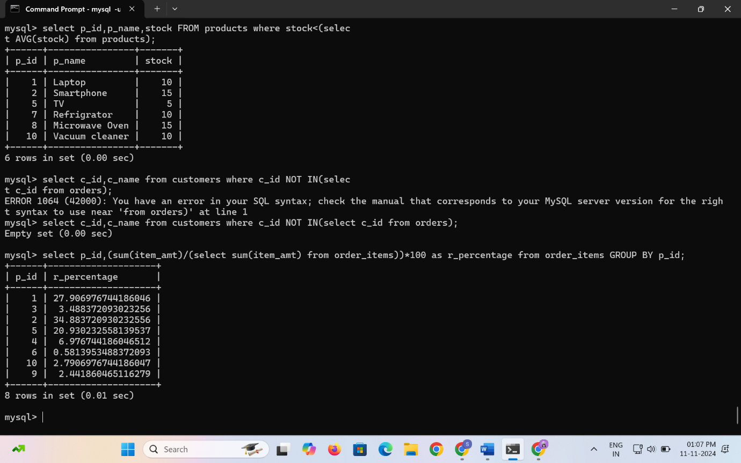

**QNS 17: Subquery to Calculate the Percentage of Total Revenue for a Product.**



**QNS 18: Subquery to Find Products with Low Stock.**

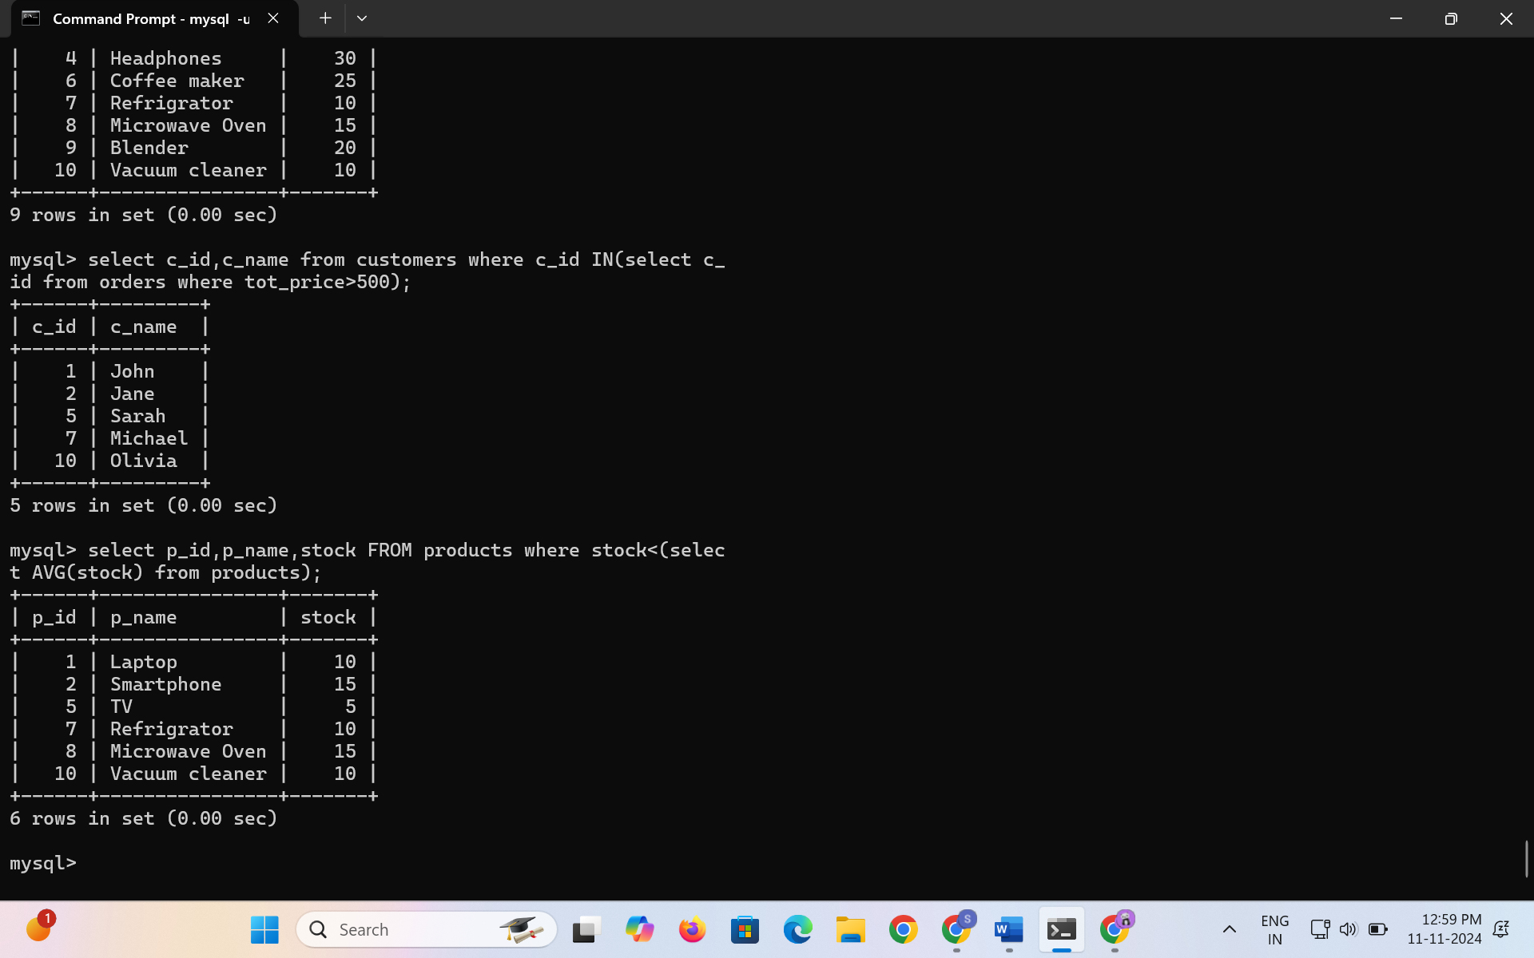

**QNS 19: Subquery to Find Customers Who Placed High-Value Orders.**

